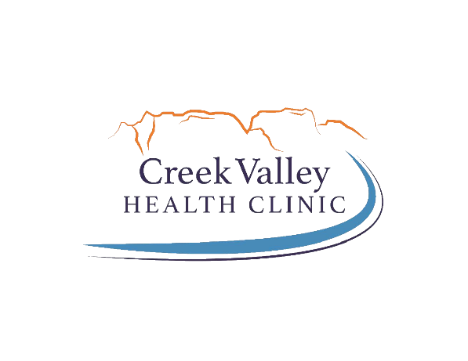 | POSITION:  Reports to:  Approved:  Revised:  Department:  FLSA: | JOB DESCRIPTION  Dental Assistant  Dental Office Manager  April 1 2024  Administration  Non-Exempt

Basic Function: Dental Assistants educate patients about procedures and dental maintenance, give instructions for oral care, order x-rays and other scans and reach out to patients about scheduling routine appointments. They set up dental exam tables, assist during cleanings and fillings and hold dental instruments like suction tubs and mirrors while the Dentist or Hygienist works. Dental Assistants also keep track of administrative duties like scheduling patients, stocking supplies and billing patients or insurance providers.

Essential Functions:
- Assisting the dentist and hygienist: Provide chair-side assistance to the dentist during dental procedures, including handing instruments, operating suction devices, and preparing materials.
- Patient care: Greet and prepare patients for dental procedures, ensuring their comfort and answering any questions they may have.
- Sterilization and Disinfection: Maintaining cleanliness and sterilization of dental instruments, equipment, and treatment areas following infection control protocols.
- Taking X-Rays: Prepare and take dental radiographs as directed by the dentists or hygienist, ensuring accurate positioning and proper exposure.
- Record keeping: Maintain accurate patient records, including treatment plans, medical histories, and consent forms, ensuring compliance with privacy regulations.
- Educating patients: provide patients with oral hygiene instructions, post-operative care information, and answer any questions they may have about their treatment.
- Instrument and equipment maintenance: performance routine maintenance on dental equipment and instruments, ensuring they are in proper working condition.
- Lab work: Assist with dental laboratory procedures such as pouring and trimming models, fabricating temporary crowns, and preparing dental impressions.
- Administrative duties: schedule appointments, manage patient billing and insurance claims, and perform other administrative tasks to support the efficient operation of the dental office. 3
- Team collaboration: Collaborate with other members of the dental team, including dentists, dental hygienists, and administrative staff, to provide quality patient care in a professional environment.
- Specialty tasks assigned by supervisor: _________________________________________.

Appearance Standards:
This position shall follow the appearance standards as outlined in the Personnel Policy “Dress and Personal Appearance”.

Required Qualifications:
- Basic Life Support (BLS): Certification in basic life support skills such as CPR, required for emergency situations.
- Communication skills: Ability to effectively communicate with patients, colleagues, and other healthcare professionals.
- Basic computer skills and knowledge of word processing software
- Organizational skills: Strong organizational skills to manage patient records, appointments, and administrative tasks efficiently.
- Posses a valid driver’s license
- Ability to maintain confidentiality at all times in all situations and follow the laws and intent of the most current HIPAA laws and regulations, including Creek Valley Health Clinic’s security and privacy practices
- Ability to read, write and speak clearly understandable English.
- Infection control knowledge

Preferred Qualifications:
- Completion of an accredited dental assisting program and/or state licensure/certification requirements.
- X-ray certification
- Previous dental assisting experience
- Experience working in a FQHC or RHC
- Expanded functions certification for coronal polishing, sealant application, or fluoride application
- Knowledge of dental terminology
- Firm understanding of Colorado City, Hildale and the surrounding area.

Physical Requirements:
Ancillary Staff
 | Not Applicable | Occasionally | Frequently | Constantly
Stand |  |  | Χ
Vision - near |  |  |  | X
Vision – w/assistance |  |  |  | X
Walk |  |  | X
Sit |  |  |  | X
Handling |  |  |  | X
Reach outward |  |  | X
Reach above shoulder |  |  | X
Climb |  | X
Crawl |  | X
Squat/kneel |  |  | X
Bend |  |  | X
Lift/Carry
10 lbs or less |  | X
11-20 lbs |  | X
21-50 lbs |  | X
51-100 lbs |  | X
Over 100 lbs | X
Push/Pull
12 lbs or less |  | X
13-25 lbs |  | X
26-40 lbs |  | X
41-100 lbs | X
Not applicable | Activity does not apply to this position
Occasionally | Position requires this activity up to 33% of the time (0-2.5 hrs per day)
Frequently | Position requires this activity from 33%-66% of the time (2.5-5.5 hrs)
Constantly | Position requires this activity more than 66% of the time (5.5 hrs +)

OSHA CATEGORY CLASSIFICATION:
I understand that the duties that are required of me place me in a Category II.

While performing the duties of this position, the employee is exposed to weather conditions prevalent at the time. The employee may experience exposure to dust, pollens, pollutants, fumes, and communicable diseases as related to the health care environment. The noise level in the work environment is usually moderate.

Travel is is not required. It is anticipated that travel will be:
5% – 10% 50%-75%
10% – 25% 75% - 90%
25% – 50%

The specific statements shown in each section of this Job Description are not intended to be all-inclusive. They represent typical elements and criteria considered necessary to perform the job successfully. The job’s responsibilities/tasks may be modified and/or expanded over time. Creek Valley Health Clinic will inform the employee when changes in the respective job description are made.

I have read and understand the duties / physical requirements indicated in this job description and acknowledge that I am able to perform these duties with or without reasonable accommodation. I understand that failure to adhere to these responsibilities could be grounds for disciplinary action.

___________________________________________________________________________________
Print Name Signature

